Year 9 – Term 3 – Science Revision

1. **Describe** each of the following in terms of where they are located, their weight and what charge they carry:
2. Proton:

Nucleus, 1, 1+

1. Neutron:

Nucleus, 1, No charge

1. Electron:

Around the nucleus, 0, 1-

1. Using a periodic table, **identify** the number of each type of subatomic particle for the following elements:

|  |  |  |  |
| --- | --- | --- | --- |
| Atom | Protons | Neutrons | Electrons |
| Helium | 2 | 2 | 2 |
| Nitrogen | 7 | 7 | 7 |
| Silicon | 14 | 14 | 14 |
| Chromium | 24 | 28 | 24 |
| Arsenic | 33 | 42 | 33 |
| Thallium | 81 | 123 | 81 |

1. **Explain** how the following are different to an atom.
2. Compound:

A compound is made up of two or more different types of atom.

1. Ion: (answer should explain cations and anions)

An atom that has lost or gained electrons and has a charge as a result A cation has lost an electron and an anion has gained an electron.

1. Isotope:

Atoms of the same element (same protons and electrons) with varying numbers of neutrons.

1. **Construct** a diagram showing the electron configuration of the following 20 elements. Your answer should have the electrons in shells.

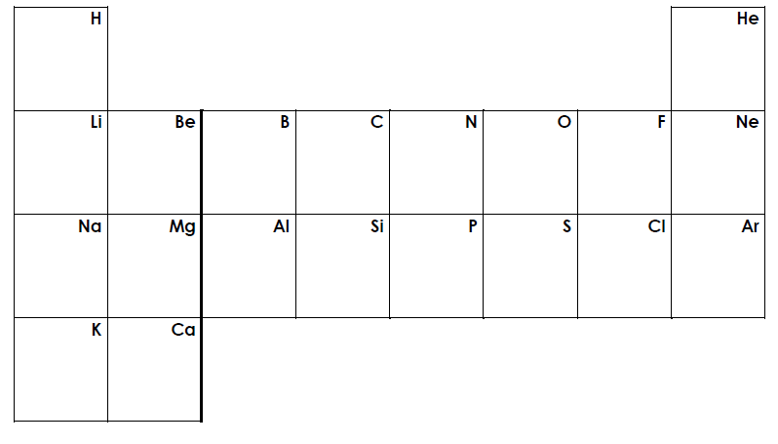

1

2

2, 1

2, 2

2, 7

2, 6

2, 5

2, 4

2, 3

2, 8

2, 8, 1

2, 8, 2

2, 8, 5

2, 8, 4

2, 8, 3

2, 8, 8

2, 8, 7

2, 8, 6

2, 8, 8, 1

2, 8, 8, 2

1. **Identify** the reactants and products in the following chemical reactions. **Construct** a word equation for each reaction.

Reactant Products

1. Sulfur burning in oxygen to form sulfur dioxide

Sulfur + oxygen 🡪 sulfur dioxide

1. Magnesium burning in oxygen to form magnesium oxide

Magnesium + oxygen 🡪 magnesium oxide

1. Sodium fluoride forming when sodium is reacted with fluorine gas

Sodium + Fluorine 🡪 Sodium fluoride

1. Nitrogen reacting with hydrogen to form ammonia (NH3)

Nitrogen + hydrogen 🡪 ammonia

1. The formation of phosphorus tribromide by reacting phosphorus and bromine.

Phosphorus + bromine 🡪 phosphorus tribromide

1. Hydrochloric acid reacting with sodium hydroxide to form sodium chloride and water.

Hydrochloric acid + sodium hydroxide 🡪 sodium chloride

1. Copper oxide and carbon dioxide forming when copper carbonate is decomposed by heating it strongly.

Copper carbonate 🡪 Copper oxide + carbon dioxide

1. Hydrochloric acid reacting with copper carbonate to form copper chloride, carbon dioxide and water.

Hydrochloric acid + copper carbonate 🡪 copper chloride + carbon dioxide + water

1. Aluminium reacting with sulfuric acid to form aluminum sulfate and hydrogen gas.

Aluminium + sulfuric acid 🡪 aluminium sulfate + hydrogen

1. Iron chloride and hydrogen gas being produced when hydrochloric acid reacts with iron.

Hydrochloric acid + iron 🡪 Iron chloride + hydrogen

1. **Identify** the correct second half to complete the following sentences:

|  |  |  |
| --- | --- | --- |
| **First Half of sentence** |  | **Second Half of sentence** |
| 1. Nuclear radioactivity refers to radiation |  | 1. Nuclei in the ground and cosmic rays from space |
| 1. Background radiation is caused by unstable |  | 1. Alpha and beta particles, and gamma rays |
| 1. Most of the radiation we receive comes |  | 1. Are called radioisotopes |
| 1. There are three types of nuclear radioactivity, |  | 1. From background radiation |
| 1. Unstable, radioactive isotopes of elements |  | 1. Made in a nuclear reactor |
| 1. Radioisotopes occur naturally and can also be |  | 1. Given out by unstable atomic nuclei |

1. **Identify** the terms from the pool of terms, which are related to each of the three types of radiation.

Alpha radiation

β

Energy in the form of a wave

Can only be stopped by a thick sheet of lead

Can be stopped by a piece of paper or dead skin

Beta radiation

α

γ

Made of two protons and two neutrons

Made of an electron

Can be stopped by a sheet of aluminium

Gamma radiation

1. Complete the following radioactive decay equations and **identify** the type of decay that occurs.
$${}_{90}^{232}{Th}→ {}_{88}^{228}{Ra}+ {}_{2}^{4}{He}$$

$${}_{29}^{64}{Cu}→ {}_{30}^{64}{Zn}+ {}_{-1}^{0}e$$

$${}_{84}^{216}{Po}→ {}_{82}^{212}{Pb}+ {}_{2}^{4}{He}$$

$${}_{4}^{10}{Be}→ {}_{5}^{10}B+ {}_{-1}^{0}e$$

$${}_{89}^{225}{Ac}→ {}_{87}^{221}{Fr}+ {}_{2}^{4}{He}$$

$${}_{93}^{237}{Np}→ {}_{91}^{241}{Pa}+ {}_{2}^{4}{He}$$

$${}_{87}^{222}{Fr}→ {}_{88}^{222}{Ra}+ {}_{-1}^{0}e$$

$${}_{51}^{125}{Sb}→ {}_{52}^{125}{Te}+ {}_{-1}^{0}e$$

2. The half-life of polonium-218 atoms is approximately 3 minutes. What does this mean?

The half-life of a species is the time it takes for the concentration of that substance to fall to half of its initial value. This means that after 3 minutes, 50% of the original polonium-218 atoms would have decays. After 6 minutes, 75% of the original polonium-218 atoms would have decayed.

1. **Explain**, in terms of reaction types, what is happening during the following reactions. Classify them as endothermic or exothermic chemical reactions.
2. Cracking a glow stick.

Exothermic as the reaction is producing energy in the form of light.

1. Using an instant icepack.

Endothermic as the reaction is absorbing energy from the environment.

1. Use the table below to **describe** how a Bunsen burner can show both complete and incomplete combustion.

|  |  |  |  |
| --- | --- | --- | --- |
|  | Flame colour | Products | Amount of oxygen |
| Complete combustion | Blue | Carbon dioxide (CO2) and water (H2O) | Excess amounts of oxygen |
| Incomplete combustion | Yellow | Carbon monoxide (CO) and water (H2O) | Limited amounts of oxygen |

1. Complete the following for the reaction between Propane (C3H8) and oxygen (O2).
2. When propane goes through complete combustion
3. **Identify** the reactants and products.

Reactants: Propane and oxygen. Products: Carbon dioxide and water

1. Complete a word equation for the reaction

Propane + oxygen 🡪 Carbon dioxide + water

1. Complete a balanced chemical equation for the reaction

C3H8 + 5O2 🡪 3CO2 + 4H2O

1. When propane goes through incomplete combustion
2. **Identify** the reactants and products.

Reactants: Propane and oxygen. Products: Carbon monoxide and water or Carbon and water

1. Complete word equations for the reaction

Propane + oxygen 🡪 Carbon monoxide + water

And

Propane + oxygen 🡪 Carbon + water

1. Complete balanced chemical equations for the reaction

2C3H8 + 7O2 🡪 6CO + 8H2O

And

C3H8 + 2O2 🡪 3C + 4H2O

1. **Identify** the word and balanced chemical equations for:
2. Photosynthesis:

Carbon dioxide + water $\underset{→}{sunlight}$ glucose + oxygen gas

6CO2 + 6H2O C6H12O6 + 6O2

1. Respiration:

Glucose + oxygen 🡪 carbon dioxide + water + energy

C6H12O6 + 6O2 🡪 6CO2 + 6H2O + energy

1. **Describe** the importance of having chemical equations that are balanced.

Chemical equations must be balanced as the law of conservation of mass states that matter cannot be created or destroyed, therefore if an atom appears on the left-hand side of an equation, it must appear on the right-hand side of an equation. This is because an atom cannot disappear during a reaction and not appear on the right-hand side, in the same way an atom cannot appear during a reaction and be recorded on just the right-hand side of the equation.

1. Using table 1, **predict** the colour each material would give if tested with the indicators shown.

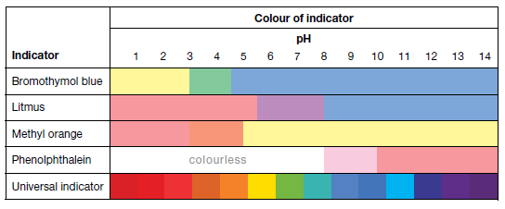

blue

blue

blue

pink

pink

pink

yellow

yellow

green

purple

orange

Light pink

purple

green

red

orange

yellow

|  |  |  |  |  |  |  |
| --- | --- | --- | --- | --- | --- | --- |
|  | pH | Litmus | Bromothymol blue | Methyl orange | Phenol-phthalein | Universal indicator |
| Floor cleaner | 10 | Blue | Blue | Yellow | Pink | Blue |
| Ammonia solution | 11 | Blue | Blue | Yellow | Pink | Blue |
| Brass polish | 9.5 | Blue | Blue | Yellow | Light pink | Blue |
| Calcium hydroxide solution | 11.9 | Blue | Blue | Yellow | Pink | Blue |
| Carpet shampoo | 5.9 | Purple | Blue | Yellow | Colourless | Yellow |
| Cream cleanser | 8.8 | Blue | Blue | Yellow | Light pink | Blue |
| Dilute caustic soda | 13 | Blue | Blue | Yellow | Pink | Purple |
| Dilute nitric acid | 1 | Pink | Yellow | Pink | Colourless | Red |
| Dishwashing liquid | 5.5 | Pink/purple | Blue | Yellow | Colourless | Yellow |
| Kitchen cleaner | 11 | Blue | Blue | Yellow | Pink | Blue |
| Lemon juice | 2.5 | Pink | Yellow | Pink | Colourless | Red |
| Milk | 6.8 | Purple | Blue | Yellow | Colourless | Green |
| Oranges | 3.2 | Pink | Green | Orange | Colourless | Orange |
| Oven spray | 12.5 | Blue | Blue | Yellow | Pink | Purple |
| Tea | 5.2 | Pink | Blue | Yellow | Colourless | Yellow |
| Toothpaste | 6.8 | Purple | Blue | Yellow | Colourless | Green |
| Vinegar | 2.9 | Pink | Yellow | Pink | Colourless | Red |
| Wine | 3.8 | Pink | Green | Orange | Colourless | Orange |

1. Colour in, using 3 different colours, the periodic table below to identify metals, non-metals and the metalloid.

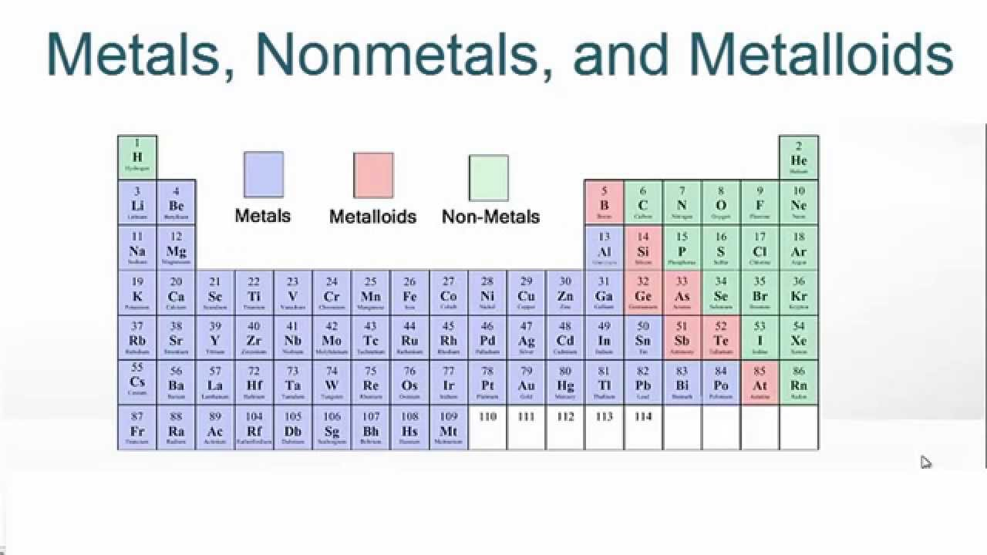

1. List the properties of acids and bases below.

|  |  |
| --- | --- |
| Acids | Bases |
| * Corrosive * Sour tase * React with some metals * Conduct electricity * Can be neutralised by bases to produce water and a salt * Release H+ | * Caustic * Bitter taste * Soapy, slimy feel * Conduct electricity * Can be neutralised by acids to produce water and a salt * Release OH- |

1. On the pH scale below, identify where strong acids, strong bases, weak acids and weak bases approximately sit. Also annotate the scale to show the difference in the concentration of H+ ions.

pH scale

|  |  |  |  |  |  |  |  |  |  |  |  |  |  |  |
| --- | --- | --- | --- | --- | --- | --- | --- | --- | --- | --- | --- | --- | --- | --- |
| Strong Acid | | | Weak Acid | | | | Neutral | Weak Base | | | | Strong Base | | |
| 0 | 1 | 2 | 3 | 4 | 5 | 6 | 7 | 8 | 9 | 10 | 11 | 12 | 13 | 14 |

Increasing concentration of H+

1. When an acid and a base are mixed together:
2. What is the name of the type of reaction? Neutralisation
3. Write a basic word equation for this type of reaction:

Acid + Base 🡪 Water + a salt

1. Explain what is different between a strong acid and a weak.

Strong acid = releasing lots of H+

Weak acid = releasing few H+

1. Identify the basic word equation for the reaction of an acid and a metal:

Acid + metal 🡪 Salt and Hydrogen gas

1. Identify the basic word equation for corrosion of copper:

Copper + Water + Carbon dioxide + Oxygen -> Copper hydroxide + Copper carbonate

1. Identify the basic word equation for the reaction of an acid and a carbonate:

Acid + carbonate 🡪 salt + water + carbon dioxide

1. Using a lit splint, how can you differentiate between the reaction of an acid with a metal, and the reaction of an acid and a carbonate.

An acid and metal reaction produces hydrogen gas, which is flammable. So putting a lit splint at the top of the test tube should produce a pop noise as the hydrogen burns.

An acid and carbonate produces carbon dioxide, which will put the flame out. So putting a lit splint at the top of test tube will see the splint go out.

1. Compare photosynthesis to respiration in terms of reactants and products, and where these reactions occur. Include as much detail as possible.

Photosynthesis – reactants CO2 + H2O, products C6H12O6 + O2. Occurs in plants during the day while they are exposed to sunlight.

Respiration – reactants C6H12O6 + O2, products CO2 + H2O. Occurs in all living things at all times.

Photosynthesis and respiration are opposite reactions as the products of photosynthesis are the reactants of respiration.

1. Explain how gas exchange between living organisms, such animals and plants, exists in a balanced relationship.

While living things exhale CO2, plants absorb the CO2 to produce glucose which is then used by living things to produce energy. In using the glucose, living thing produce CO2 which they again exhale, restarting the cycle.